10 Tips for How to Fully Feel What Hurts without Going Insane
By Lissa | 6 Comments
| Wednesday,February1st,2017
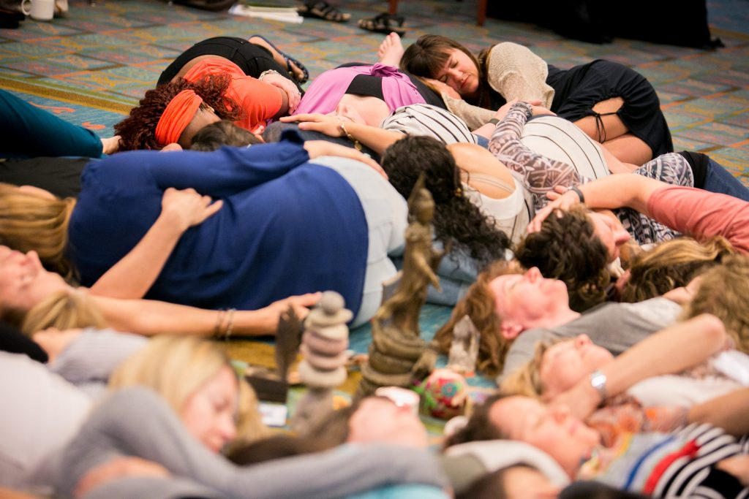
Stuff hurts right now. A lot of stuff hurts. If you’re not feeling at least some pain right now, you’ve probably numbed out with an addiction, psychiatric medication, dissociation from your body and your emotions, or maybe even some form of spiritual bypass, like meditating to transcend your human pain. If you’ve numbed out, that’s understandable. You’re human. That’s what humans do when they don’t have the emotional resilience to handle a broken heart. Whether chemically or emotionally, you’ve closed your heart, so it doesn’t have to feel so much pain. But it also cuts out your capacity to feel joy, to play, to love, to laugh, to feel gratitude, to cry at the heart-opening beauty of a sunset.
Life tests the resilience of the heart, not because there’s some punishing God who wants to see what you’re made of, but because our souls choose human experiences that teach us emotional resilience and help break the heart open. Emotional resilience is the capacity to feel the full range of human emotions all the way into our guts without shutting down or numbing out, to bench press our capacity to fully feel grief without going insane or to fully feel rage without murdering someone. When you lack emotional resilience, you also can’t handle intense waves of pleasure or heart-bursting joy. You will literally sabotage your life (consciously or unconsciously) so that you don’t have to fully feel love, gratitude, joy, and pleasure. If the heart lacks resilience, it might feel strong, because it can withstand even the most torturous pain. But it’s essentially weak because the capacity to feel is so limited. The heart is in prison, and the side effect is a dullness of spirit that leads to chronic illness, depression, addiction, and physical pain.
The collective heart is breaking right now, and I feel it, as do many others. You don’t even have to be particularly sensitive to feel the heartbreak that is crying across the globe. It is right there, in your own heart, the part that’s connected to all the other hearts out there, the part that’s connected to the suffering of Mother Earth and all her earthly creatures and plants. When any one heart breaks, all our hearts feel it on some level. When the heartbreak becomes this extreme, it simply becomes more than our human selves can handle, unless we learn emotional resilience.

How Do We Develop Emotional Resilience?
- Practice surrender.
When we resist life, we are vulnerable to the slings and arrows of what is happening outside ourselves. If you’re attached to getting what you want and avoiding what you don’t want, life is going to hurt- a lot. Because I hate to break it to you, but you’re not in control. You participate with life. Your thoughts, beliefs, feelings, and intentions participate in the co-creation process, but you’re not in charge. It’s not that simple. Cultivating a spiritual practice of surrendering to Divine Will, with the humble understanding that it’s hard to know what Divine Will is, helps cultivate emotional resilience. Don’t overdo it. Spiritual surrender can be a form of spiritual bypass, overused to avoid feeling pain. But if practiced alongside a practice of learning to feel what you feel fully, surrender cultivates acceptance of what is. Yes, it’s okay to resist what breaks your heart. Pick up a protest sign and march against the immigration ban if that’s what your heart guides you to do. But also, holding that in paradox, surrender the whole thing to Divine Will and trust that you will be shown right action. Trust that there may be a Divine perfection even to that which you might consider intolerable. Ask to be shown what serves Divine Will. Let go. (For help with this practice, read this blog, and this one. Or read my books The Fear Cure and The Anatomy of a Calling. Or read pretty much anything Tosha Silver writes.
- Set and maintain healthy relational & psychic boundaries.
Setting boundaries teaches people what’s okay and what’s not okay with you. It also means establishing consequences when those boundaries are violated. Boundaries in relationships create safety, and when you know you’re safe, you can handle greater emotional depth.
Don’t just set relational boundaries. Set psychic ones too. Get clear on what pain is yours and what pain is collective. Yes, we’re all One, so we feel collective pain personally, but if you can’t handle the amount of pain you’re feeling right now, you can choose to boundary yourself against feeling all the collective pain. Setting good psychic boundaries starts with intention and invocation. Make it clear that you need a break from the collective psychic pain, at least for a while. Allow yourself to overdose on joy, pleasure, and gratitude, not as a spiritual bypass, but as an antidote to unbearable pain.
- Surround yourself with people who uplift you.
If you’re surrounded by energy vampires, pessimists, and those who are stuck in their victim story, you’re probably co-dependent, stuck in the drama triangle, hooked in by your Savior Complex. That pattern is a prison and it will suck you dry. Get out. Refuse to participate. Boundary yourself against anyone who insists on trying to suck you into the drama triangle. If you can’t resist this pattern, you will lack emotional resilience. Your heart simply won’t be able to handle it. Grant yourself permission to surround yourself with those who cultivate the stillness in you and leave your heart feeling peace.
- Cultivate awareness of your needs.
Spiritual practice deepens your self-awareness, granting you awareness of how you feel and what you need when you’re feeling emotional pain. As yourself “What do I need right now?” Can you become aware of what would comfort you? Can you be brutally honest with yourself without beating yourself up? What do you need? Get to know yourself.
- Ask for what you need.
Use non-violent communication and always give someone permission not to meet your need if they don’t have the bandwidth to do so. This is a vulnerable process that requires a lot of inner strength. Our culture teaches us that it’s weak to be “needy,” that strong people meet their own needs. Yes, it’s helpful to be able to ReSource yourself, to go inward to get your emotional needs met. But we are also tribal beings. We need one another, especially when our pain gets so great that we simply can’t handle it on our own. Sometimes you need someone to hold you. Sometimes you need someone to just sit and hold space and listen. Sometimes you need someone to just be with you in silence while you cry. This is not an excuse to be co-dependent or manipulative, using some fake or inflated need as a cry for attention- when what you really need is attention. If you need attention, ask for attention. It’s okay to need emotional support. The awareness of when to ask for it and the courage to ask is a strength, not a weakness.
- Prioritize relationships with those who want to and are capable of meeting your needs.
Remember, I’m not talking about co-dependence or drama triangles. I’m talking about how to become more emotionally resilient. You’ll find plenty of co-dependents who will want to meet your needs. Say no to them. Say yes to those who are healthy in their boundaries and loving in their hearts, the ones who have so much love bubbling out of their hearts that it’s just looking for a place to land, the ones who feel called to meet your needs- because they love you and they want that intimacy with you. No one person will be able to tend to every one of your needs, so spread it out. A healthy person will say, “I really want to meet that need but I don’t have the bandwidth right now, because I’m too needy myself. Can you ask someone else this time, but feel free to keep asking, because next time, I’d love to help if I can.” Nothing wrong with that. Totally fine.
But pay attention to the ones who never let you have needs or who criticize, belittle, shame you, or even attack you for being “needy.” If someone is always unwilling or unable to demonstrate sensitivity and a desire to help you get your needs met, why are you still in relationship with them? There is vulnerability and strength in being able to ask yourself, “What do I need?” then to be brave enough to ask for help. Those who can’t do this commit suicide, and everyone says, “Why didn’t they ask for help?” Because our culture tells us it’s not okay to need support when we’re hurting. Because those who commit suicide lack emotional resilience.
Healthy people appreciate the intimacy of that comes with that kind of vulnerability. They want to meet your needs, and you’ll want to meet theirs. (If you don’t, if someone is always meeting your needs but you’re never meeting theirs, you’re playing out a Narcissus-Echo pattern. Break that one too if you intend to develop emotional resilience.)
- Come into right relationship with uncertainty.
If you can’t handle not knowing, you’ll become a control freak. You’ll try to practice “the law of attraction” so you can “manifest” everything you want and avoid everything you don’t want. Then life will prove to you that it doesn’t work that way, at least not for long. You participate with life, but you are not in charge. Humble yourself before the mystery. Be curious in the face of uncertainty. Don’t let fear overcome you. Let it arouse your curiosity. When you don’t know what’s going to happen, anything can happen- even a miracle. If you can’t learn this life skill, life will prove to you that you’re not in control, and you’ll be vulnerable to a breakdown.
- Meditate.
Get comfortable being silent and doing nothing. Resist the temptation to numb yourself with busyness and distraction. Sit with what hurts and just let it wash through you like a wave. Emotional pain and heartbreak are like labor pains. Those waves of pain are coming, and if you resist them, it hurts more and can obstruct the birth process. If you lean into the pain, soften into the pain, accept the pain, rather than resist it, the pain moves through you like a contraction and then releases until another contraction moves through. Let these waves move through you while you sit with them in silence. Ask someone to hold you if it helps.
- Practice radical self-care.
When something hurts and you’re not sure you can handle it, have a ready list of self-care activities that you can call upon for comfort. (Try these tips or listen to these songs). Many people resist self-care when they need it the most, beating themselves up or shaming themselves or bullying themselves into trying to buck up and force function or engaging in spiritual practices as a spiritual bypass, pretending as if they’re not in pain, denying what they feel. It’s okay to need radical self-care when you’re hurting. In fact, it’s preventive medicine. It could even save your life.
- Be creative.
When you’re stuck in your head, ruminating over painful stories, the pain can be overwhelming. But if you take your broken heart and turn it into art, writing, music, or some other engagement with the muse, the muse will help you heal. (Need help getting in touch with your muse? Check out pretty much anything my sister priestess goddess artist Shiloh Sophia McCloud is doing).
Humans are made to be strong and resilient. We can feel intense emotional pain and still survive it. We can even let pain transmute into spiritual gold.
We can get through hard times together, beloveds. We need each other now more than ever. We Love Warriors have got each other’s backs. In fact, we’ve got everyone’s backs, even those you might be tempted to judge. Everyone gets included in the sphere of love we are co-creating.
Cracked open,

